Visit Report: Amtoli Upazila Health Complex, Barguna
Date of Visit: 25/08/22; Time: 8:45 AM.
Visitor: Dr. Md. Emdadul Haque, National Consultant (HEU) &
Dr. Nazmur Rahman Sajib, Junior National Consultant (HEU)

1. We arrived at 8:45 am in the health complex. But no medical officer except EMO was present in the health complex.
2. The infra-structure of this Upazila Health Complex is 50 bedded. The physical condition of the hospital building is good. The UHC is situated close to the high way. There are 7 unions under this UHC.
3. We met with the RMO and other Medical Officers, discuss with them about the overall situation of health complex. The post of Gynae and Anaesthesia consultant was vacant, so caesarean section is not performed.
4. We visited outdoor of the Upazila Health Complex of Amtoli. The outdoor was crowded with patients. We observed OPD, Emergency, labour room, pathology and pharmacy department. There are two medical technologist (Lab). The information display system was better than any other UHC of Barguna district, but the health education system is weak.
5. Cleanliness of the hospital premises and indoor was satisfactory. There is a separate operation theatre but not functioning.
6. There is no cycle stand close to the main gate. There are many motorcycles parked within corridor.
7.The roof of the health complex is not clean. There are many bushes and unwanted hospital beds and other items on the roof.
8.There are many spaces in emergency, SSK Booth and Pharmacy can easily be established there.
9.There are many “Danbox” throughout the UHC, and advised for removing those immediately.
10.The UHC was awarded by “Health Minister’s Award” in 2015.
Health Profile of Amtoli UHC, Amtoli, Barguna
Total population: 244,438
Union: 7 Sub-centre: 2 FWC: 7 Community Clinic: 29

Human Resources: 50 Bedded Hospital:
Sl. | Designation | No. of Post | Present | Vacant
1. | UH&FPO | 1 | 1 | 0
2. | Junior Consultant | 11 | 0 | 11
3. | Medical Officer | 3 | 3 | 0
4. | Medical Officer (OSD) | 7 | 6 | 1
5. | Nurses | 30 | 30 | 0
6. | Mid wives | 4 | 4 | 0
7. | Medical Technologist (Lab) | 3 | 2 | 1
8. | MT EPI | 1 | 1 | 0
9. | Dental Technologist | 1 | 0 | 1
10. | MT (Radiology) | 1 | 1 | 0
11. | SACMO | 4 | 4
12. | Health Inspector (HI) | 2 | 0 | 2
13. | Assist. Health Inspector | 7 | 7
14. | Health Assistant | 21 | 19 | 2
15. | CHCP | 29 | 29
16 | Head Assistant | 1 | 0 | 1
18. | Accountant/Statistician | 2 | 1 | 1
19. | MLSS | 4 | 2 | 2
20. | Cleaner | 5 | 4 | 1
21. | FWA | 21 | 21 | 0
22. | Outsourcing: Cleaner, Cook, Guard, Ward boy, Aya. | 4 | 1 | 3

Status in HSS Score From Jan-July. (Total Dist. Hospital-64, Total UHC-423)
Name | Janu | Feb | Mar | April | May | June | July
Barguna D-Hospi | 03 | 07 | 19 | 22 | 21 | 16 | 19
Amtoli UHC | 319 | 200 | 255 | 298 | 207 | 368 | 353
BetagiUHC | 306 | 314 | 304 | 332 | 340 | 337 | 341
BamnaUHC | 221 | 162 | 290 | 230 | 279 | 277 | 279
PathorghataUHC | 209 | 291 | 347 | 258 | 248 | 270 | 385
Taltoli UHC | - | - | - | - | - | - | -
Status of Building Blocks of C-J Model in the Amtoli UHC:
Sl | Criteria of C-J Model | Best | Good | Weak
 | Cycle stand close to the main gate |  |  | √
 | Health Education |  | √
 | Cleanliness & beautification | √
 | Separation of patients in out door & indoor |  |  | √
 | Blood doner list with 24/7 B.T facility |  | √
 | Birth- death recording |  |  | √
 | Reception Desk |  |  | √
 | Developed Emergency Dept. |  | √
 | 5S –KAIZEN implementation. |  | √
 | Community Participation. |  | √
 | Hospital activities Display |  | √
 | Corner based service. |  | √
 | Cash counter for receiving Govt money. |  |  | √
 | Devolped maternal health/labour word. |  |  | √
 | Devolped paediatric health |  |  | √
 | Position in HSS score  (Best= <100; Good= 101-200; Weak= >200) |  |  | √
 | Power point Presentation &Video on UHC |  | √
 | Knowledge about 8th Five Year plan & SDG. |  |  | √
 | Zero-Tollarance on corruption |  | √

Recommendations:
1. For better office management, the post of Head Assistant and Statistician is very important. Both the post is lying vacant. It should be filled up immediately.
2. Cleanliness and beautification is satisfactiry. The local Powroshova must take part in waste management.
3. There is an OT room in the health complex, but not functioning.
4. Labor room is well functioning.
5. Condemetion Board should work to destory all unwanted items.
6. All the post of consultants especially Gynae consultant and Anesthesia should be filled up immediately .
7. Medical Technologist (Dental) is necessary for dental deptt.
8. Replication of C-J model will help in development of the quality of care and it should be followed properly.
9.All the vacant posts of 4th class should be fulfilled immediataely.
10. Radiogical service is not functioning.Vaccant post of radiographer shoul be fulfilled.
11. There should be a Complains and Suggestion box in front of UH&FPO room
12. The roof of the health complex building should be clean.
13. All the “Danbox” of the UHC, should be remove.
14. By dividing of a large room close to Emergency Dept. a site for SSK Booth& a Pharmacy built is possible.

Photos of UHC, Amtoli taken from the visit are shown below:
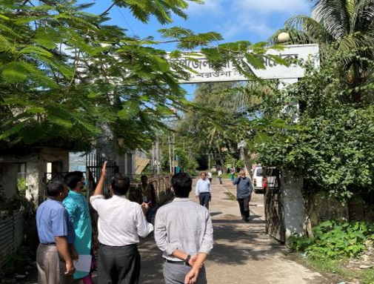
Fig-1: Front Gate of the Amtoli UHC

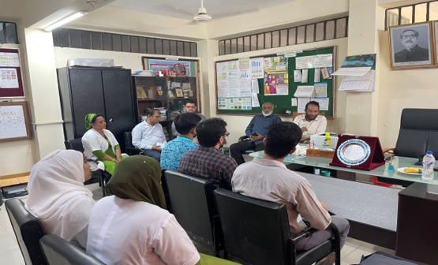
Fig-2: Meeting with the RMO and Medical Officers
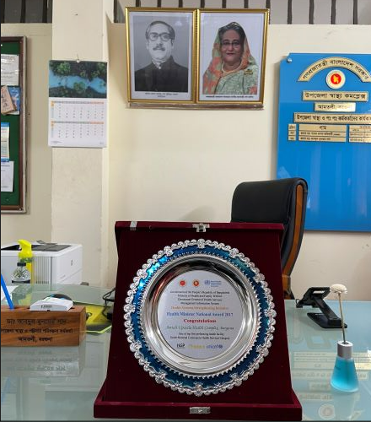
Fig-3: Health Complex is nationally awarded in 2017

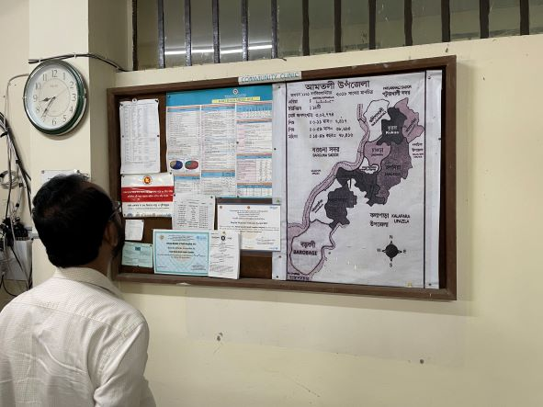
Fig-4: Improved Display System but not updated
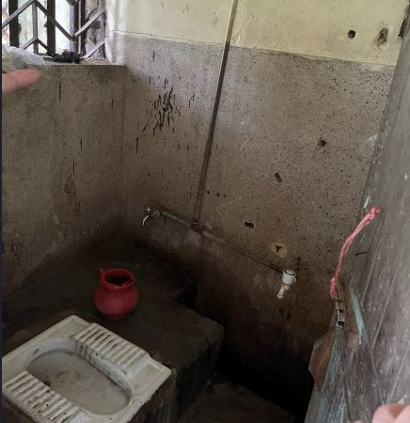
Fig-5: Unclean toilets in the health complex

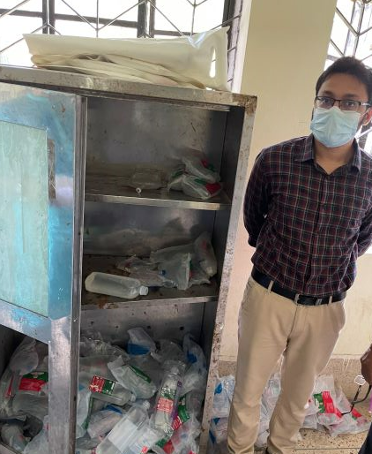

Fig-6: I/V-fluids not preserved safely and properly
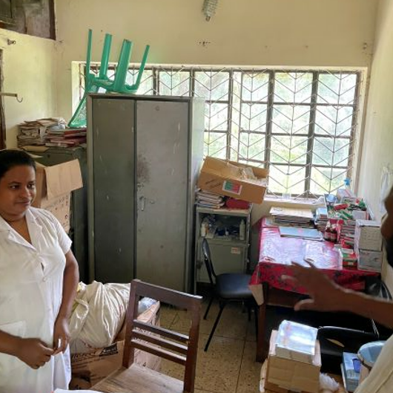
Fig-7: Unwanted items in nurse’s duty room
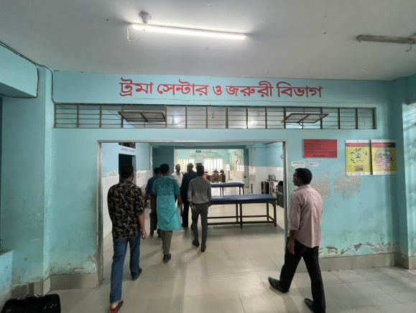
Fig-8: Privacy is not maintained in Emergency Dept

